Enhancing Confidence to Improve Performance: Sunday 27th October 2018

Booking and payment form

Payment methods:

Cheques payable to ‘YAA Coaching”
Postal address: Mrs K B Fitzpatrick, 5 Wilson Grove, Lundwood, Barnsley S71 5JS

BACS payment: HSBC Barnsley, Bank A/C 72129244 sort code 40-09-12
Cash – payable on the day (non-attendance will be invoiced)

Please list below those attending:

Name | Club | Any dietary requirements

Please detail any access assistance you may need.

Programme for the day

9.45 – 10.15am Arrival / refreshments

10.30 Workshop – Enhancing Confidence to Improve Performance, Erin Prior
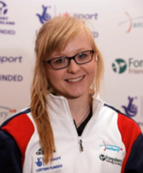
Erin Prior is a trainee Sport & Exercise Psychologist who has a BSc in Psychology and an MSc in Sport & Exercise Psychology from Loughborough University. Erin has also been a competitive archer for 11 years. 6 years recurve and 5 years compound and has competed at county level with both bow styles and competes nationally and internationally in compound. As a result, Erin has sound knowledge of both the technical and psychological demands of archery.

1.30 (approx..) Lunch (provided)

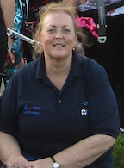
2.30 (approx.) Practical session: shooting and coaching – technical session – understanding the anatomy of the shot, developing form, understanding alignment and how to achieve it.

led by Kath Fitzpatrick, Archery GB Talent Team Coach:
6 years as National Academy Coach, including 3 years as Lead Performance Coach, Northern Academy.
Senior Coach since 1994, Coach Educator. Currently lead coach, Arrowhawks Archery Academy.

5.00 Close

