Sport Psychology Workshop Sunday November 4th 2018

Following on from last year’s successful weekend of Sport Psychology with GB Archer and Sport Psychologist Erin Prior, we are pleased to be hosting another weekend with a new workshop “Enhancing Confidence to Improve Performance” Details below

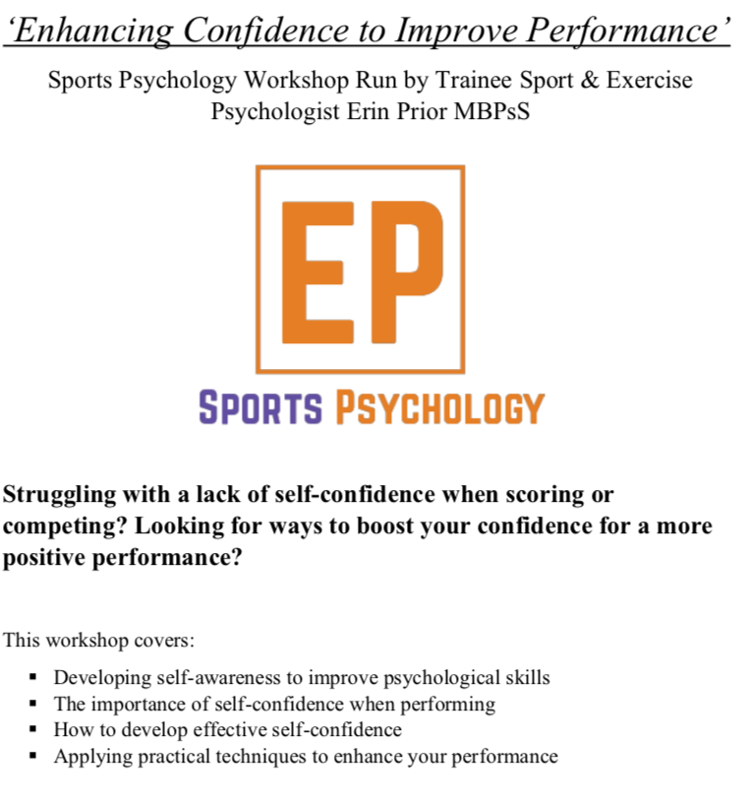
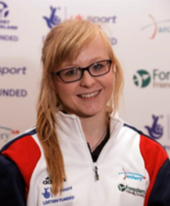

Erin Prior is a trainee Sport & Exercise Psychologist who has a BSc in Psychology and an MSc in Sport & Exercise Psychology from Loughborough University. Erin has also been a competitive archer for 11 years. 6 years recurve and 5 years compound and has competed at county level with both bow styles and competes nationally and internationally in compound. As a result, Erin has sound knowledge of both the technical and psychological demands of archery

This workshop is suitable for archers and coaches of all levels and abilities; no prior knowledge or experience of sport psychology is necessary.

The session will start c 10-30 and refreshments will be available from 9-45.
A light buffet lunch will be provided. Following this there will be an opportunity to explore key concepts of developing good form, whether recurve or compound, and understanding the anatomy and development of the shot cycle. Bring your bows!

Cost for the full day: £30.00 including lunch. Please state if vegetarian, vegan or halal.

Booking details on the attached form

